A000-Eur-Scottish Celtic-Claidheamh-mòr Dagger –c 900 CE

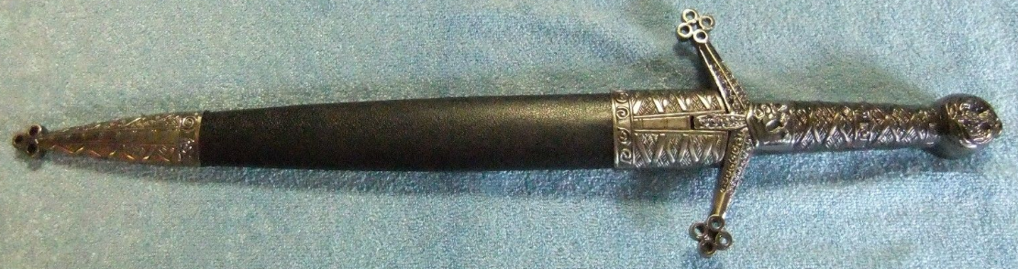 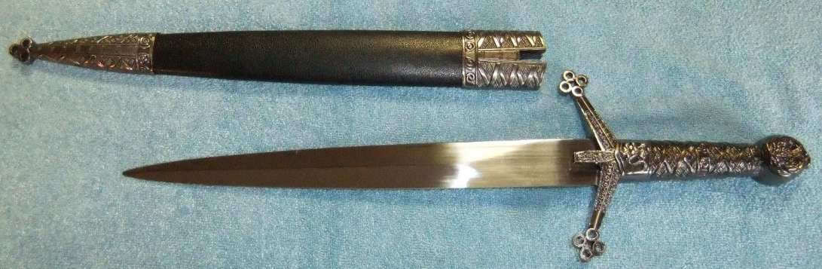

Scottish Celtic-Claidheamh-mòr Dagger –c 900 CE

**Case No.: 4**

**Accession No.**

**Formal Label:** Scottish Celtic-Claidheamh-mòr Dagger –c 900 CE

**Display Description:**

This claidheamh-mòr (“great sword”) dagger is one type of the daggers used by Celts in the Scottish Highlands during Medieval times. Originally, “Scottish Celtic-Claidheamh-mòr referred to a very large two-handed long sword, but now it has come to define any bladed weapon with a cross hilt of forward sloping quillons and quatrefoil terminations.

**Accession Number:**

**LC Classification: DA880.H8**

**Date or Time Horizon:** 900 CE

**Geographical Area:** Scotland

**Map:**

**GPS coordinates:**

**Cultural Affiliation:** Scottish Celtic

**Medium:** steel and silver

**Dimensions:** •  Overall Length: 15-1/2"•  Blade Length: 9-1/2"

**Weight:**

**Condition: replica**

**Provenance:**

**Discussion:**

**References:**